Republic of Iraq
Ministry of Higher Education and Scientific Research
Al-Muthanna University
College of Education for Pure Science
Department of Mathematics

Curriculum Vitae

Personal Information
Name: Shakir Razag Abd Alkareem
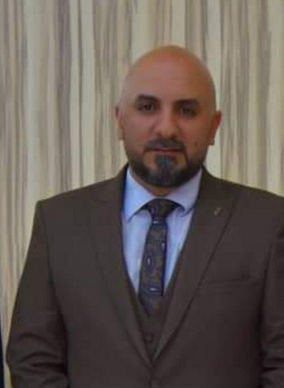
Permanent Address: Iraq – Samawha / Muthana
Edu-Mail: shakirmuthana@mu.edu.iq ,
Alternative Email: shakirmuthna@gmail.com
Mobil: 009647822249710 , 009647705544939
Place and Birth Date: Samawha – 1/ 8 /1981
Gender: Male
Nationality: Iraqi
Religion: Muslim
Social state: Married

Qualifications
- M.Sc. in Computer Science from University of BAMU, India, 2013.
- B.Sc. in Software Engineering from Al Rafdin College University , Iraq, 2004.

Thesis Title
- College Automation Online Canpos Tour. (M.Sc. Thesis)

Academic Degrees
- Assistant Lecturer from 2017/1/21.

Professional Experience
- Faculty Member as Assistant lecturer in Al-Muthana University, College of Education for Pure Science, Department of Mathematics, Samawah, Iraq.

Area of Specialization
- Operating Information .

Skills
- I speak Arabic and English good.
- Certificate of participation in the course teaching methods from the Al-Muthanna University.

Courses Taught at
- Al-Muthanna University, College of Education for Pure Science, Department of Mathematics
- “Programming “, third stage.
- “Liner Algebra “, first stage.
- “Numerical Analysis “, third stage.

Scientific Societies
- Google Scholar: User name :- Shakir Razag
https://scholar.google.com/citations?hl=ar&user=EftkAdQAAAAJ
- ResearchGate: User name :- Shakir Razag
https://www.researchgate.net/profile/Shaker_Alkareem/research
- ResearcherID: User name :- Shakir Razag
- Publons: User name :- Shakir Razag
https://publons.com/dashboard/records/publication/import/
- ORCiD: User name :- Shakir Razag
https://orcid.org/my-orcid

Scientific Research

- ESTIMATION OF MAXIMUM TIME TO PROCESS USER REQUEST IN CLOUD COMPUTING SYSTEM
- Adoption of identification and documentation as input to machine learning layers and techniques for optimal decision

Assist. Lecturer:- Shakir Razag

